**MULTITHREADING IN JAVA BASICS**

**MULTITHREADING IN JAVA BASICS**

**MULTITHREADING IN JAVA BASICS**

**MULTITHREADING IN JAVA BASICS**

**MULTITHREADING IN JAVA BASICS**

**MULTITHREADING IN JAVA BASICS**

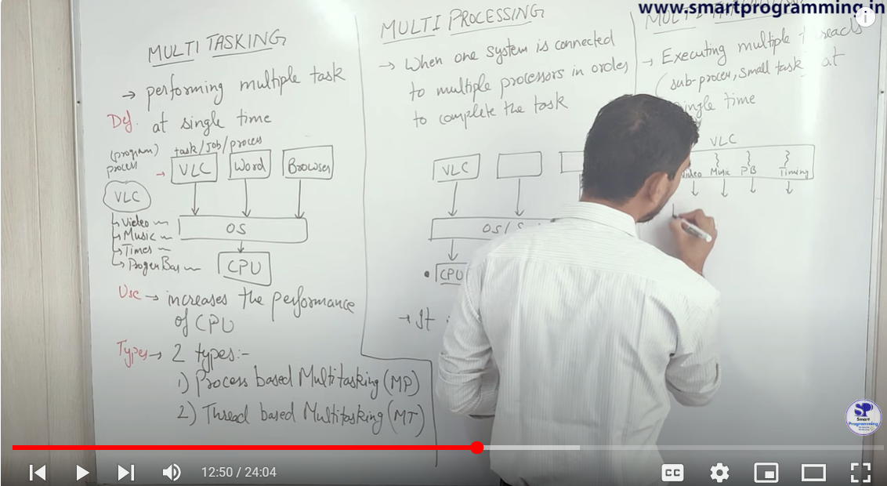

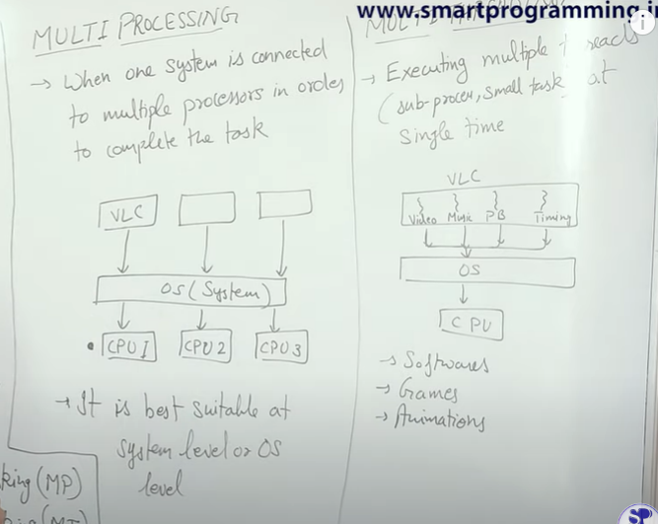

Multitasking -> Several processors are assigned to a single system

Multithreading -> Task/Job/Process breaks in to subtasks and subtasks of multiple process runs in such a way that that user things all process ( music player , word pad ) all are running simultaneously.

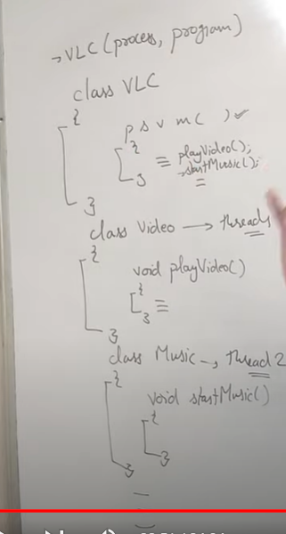

Q>Why threading?

->

Using only OOPs concepts , if we try to make a video player app like above code , we cant

Invoke music and video method simultaneously . Threading gives flexibility to user to run complex designed software efficiently.

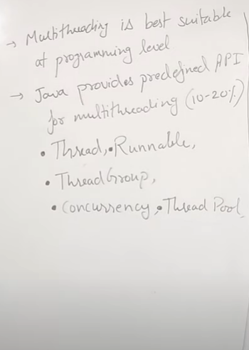

Predefined API provided by Java to handle majority of the tasks by providing inbuilt methods and interfaces to execute the process of multithreading.

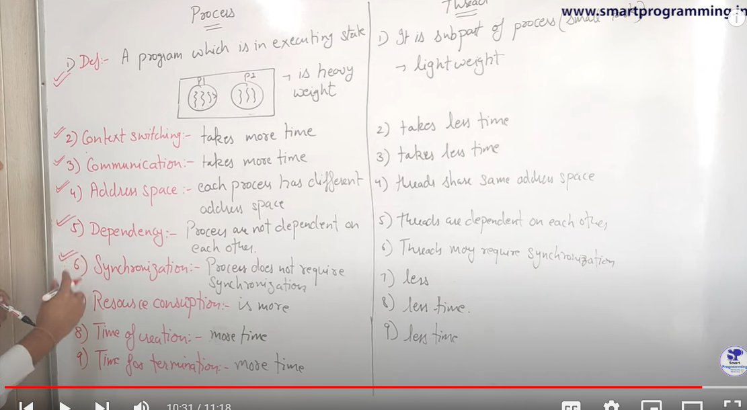

SYNCHRONIZATION

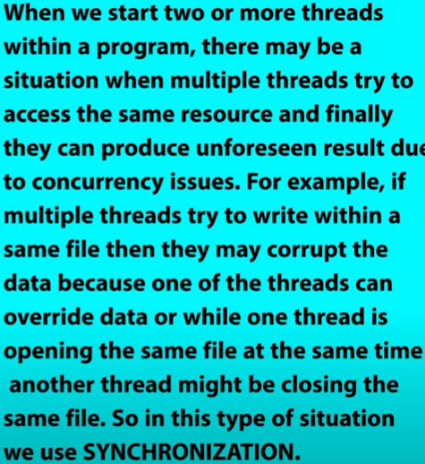

CONTEXT SWITCHING

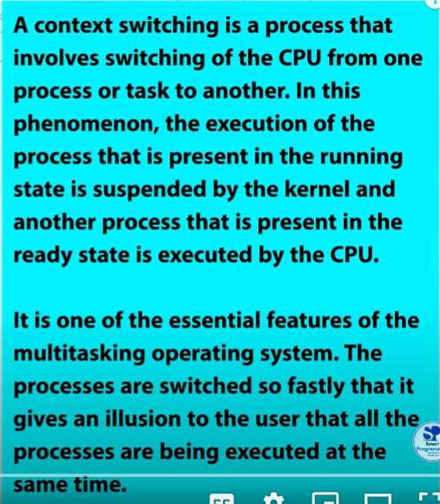

Creating Thread

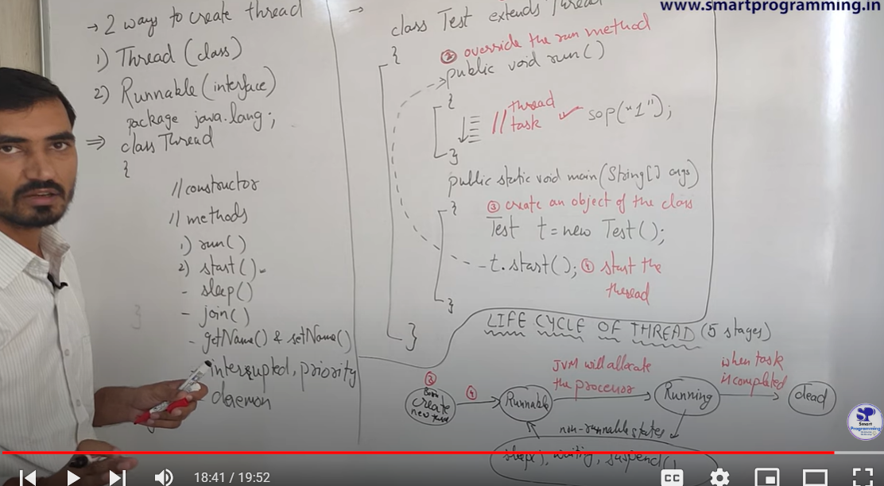

1. Using class -> Thread or Interface -> Runnable
2. Import packaga.java.lang;
3. Steps using class

i) Extends Thread class

ii)override function run()

iii)Create a object

iv)Till now no memory/thread is created. Invoke the thread.

object_name.start(); //Thread Created

1. Why not .run(); ?

.start(): Enables true parallelism by allowing multiple threads to run simultaneously . Without .start(), there is no real concurrency. The run() method just executes like a normal function, blocking the current thread until it completes . When you call .start(), it creates a new thread in the background. This new thread executes the code inside the run() method. It allows the run() method to execute concurrently with the main thread. If you directly call .run(), it will not create a new thread.

1. What is the internal difference btw thread class and runnable interface ?

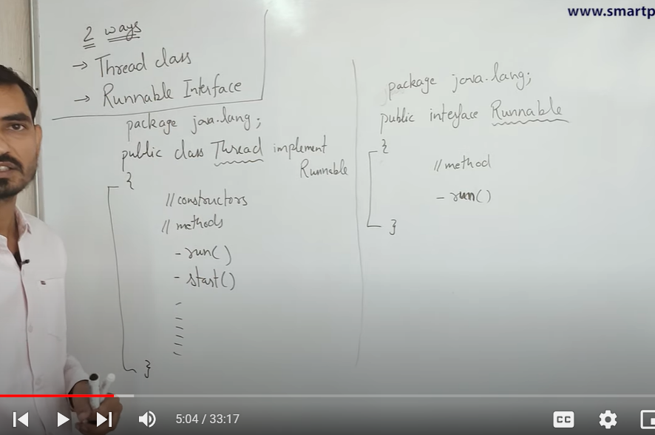

i)Thread class implements Interface.

ii)Thread class consists of multiple methods, constructors

but interface runnable has only 1 single method run().

iii)Both has common method run . Thread class overrides run method since it is an abstract method inside interface.

iv)So how to use start() if we are creating thread by implementing interface.

* In case of class implementation extending thread class , all properties of thread class is inherited . so we can create a object and directly use .start().
* But for class implementing runnable interface we need to create an additional object of thread class in order to invoke constructor by passing reference of an object of the class to the constructor of Thread class .
* So using class directly we access start() directly through an object (Inheritance) but for interface we use thread object to start(), by passing that object as a reference.

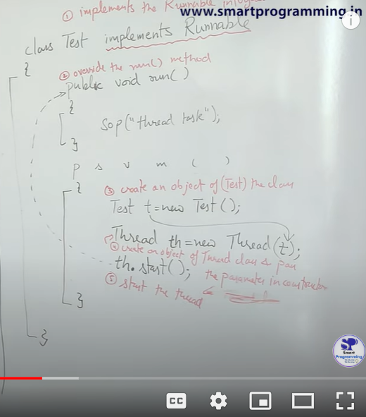

1. Steps using interface

i)Implement Interface runnable

ii)Override run method.

iii)create object of class.

iv)create object of Thread class and pass created object as reference.

Thread th = new Thread(object_name);

V)Invoke thread

th.start();

1. Which one is better ??

Since multiple inheritance is disallowed in java , in large code base we use inheritance in majority of the programs .So on extending thread class may result in redundancy of code .Runnable implementation is henceforth better.

1. So .run() treats run method as regular function and no thread is created . What if we use .start() method twice/multiple times -> We get exception(Illegal) .

Exception since once we started a thread , we cant invoke it again since start() will completely execute the task/thread job and it dies . On again calling start() , will now give an error.

1. We must ensure to pass object while using interface otherwise if not passed on executing th.start() ,compiler cant match the process/class which should be run now.

Lifecycle of THREAD

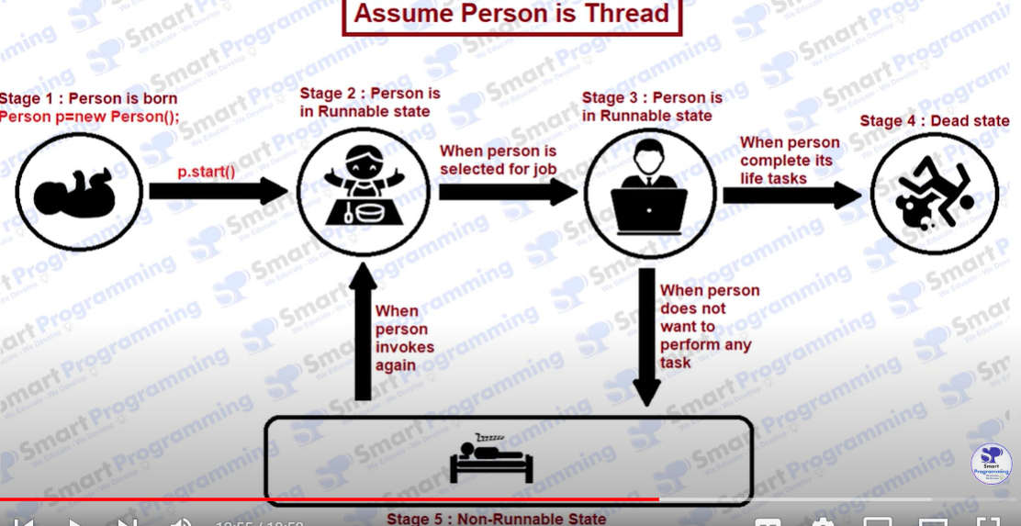

stage1 -> Thread created , stage2 ->Runnable state ( Dispatched to processor ) -> stage3 ->Executing state

stage4->may present may not present ? – let suppose it need to wait for another thread to continue or it gets suspended so it will move to non-runnable state . To get

back to runnable state it again need to be assigned to processor . stage5->Dead state or complete status.

EXECUTING CASES IN MULITHREADING

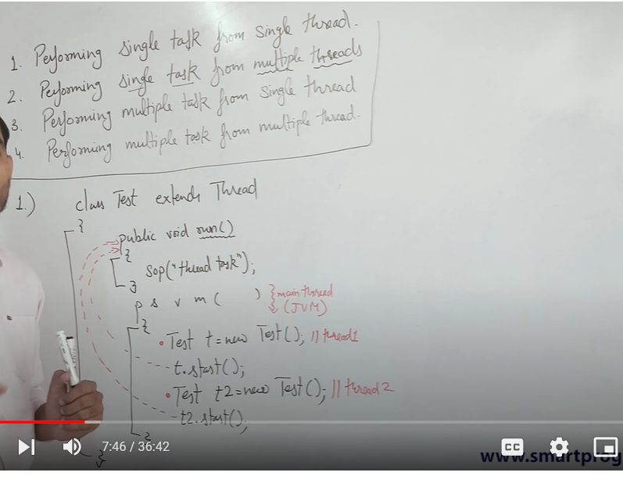

q> performing multiple task from single thread not possible ?

* Yes , since if we break a thread to perform multiple task ( video , music ) , it cant do concurrently/parallel hence multitasking not possible.

q> How many threads are created/present in above example ?

* 3 ( main thread ->default thread created by JVM).Although there are many daemon thread running in background. (A daemon thread in Java is a low-priority thread that runs in the background to perform tasks like garbage collection.)

q> if multiple thread executes , the thread created later will complete later ?

* We cant decide which thread will execute at what time or order may not be maintained . It depends on thread shedular algos , JVM e.t.c

Case 1 : Single task using single thread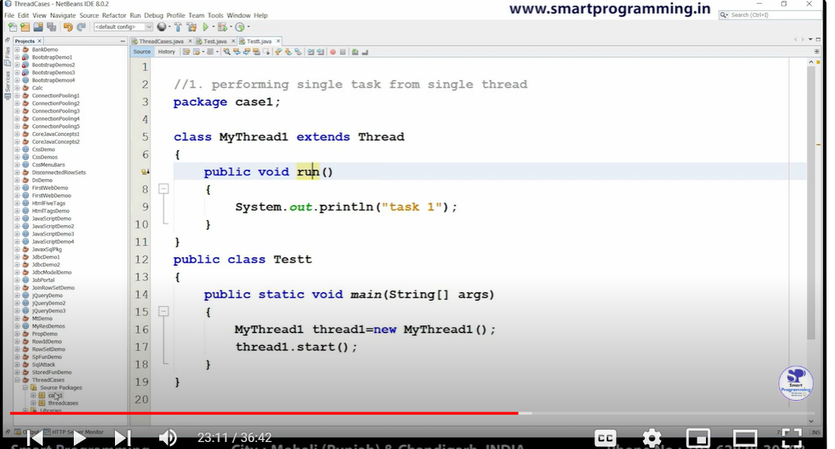

Case 2 : single task using multiple thread

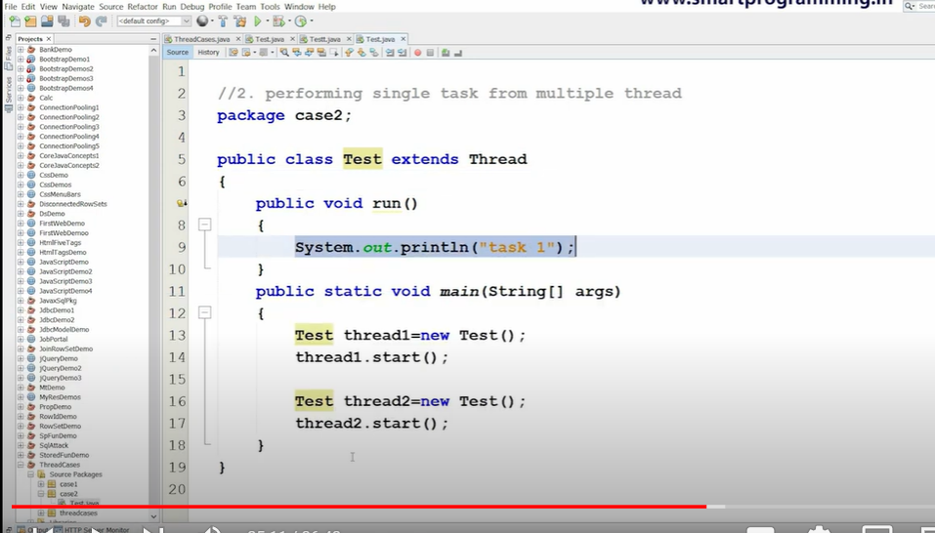

Case 3:Multiple task executed by multiple thread.

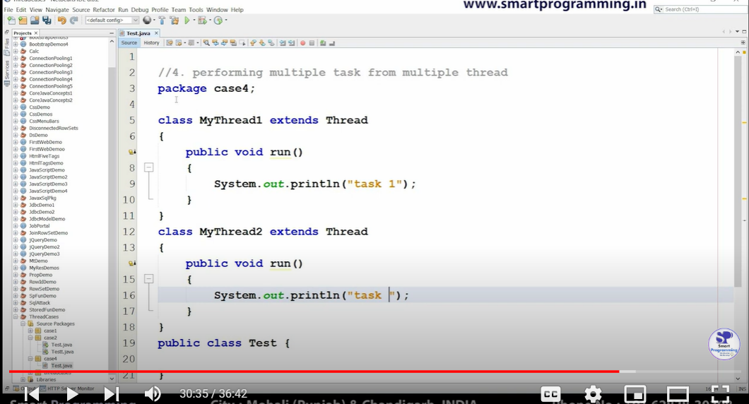

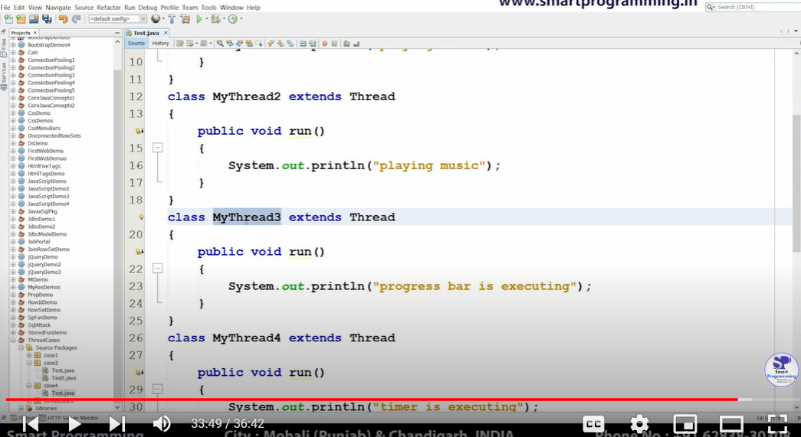

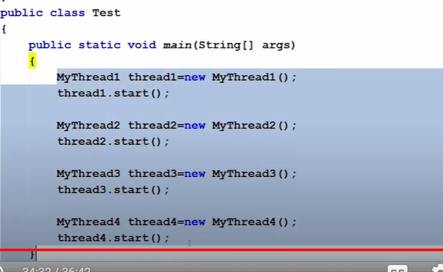

All above code have implemented Thread class. But in practical use we mostly use interface implementation

THREAD CLASS ::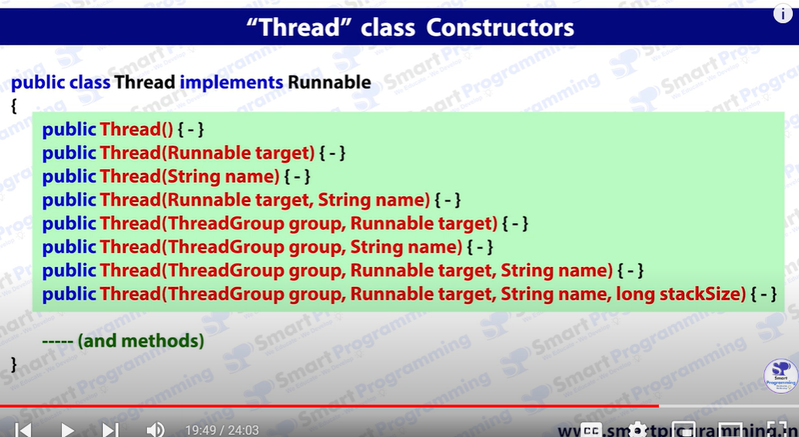

Runnable target is used to pass reference of object implementing using interface whereas simple () are for class extending Thread Class

Last 4 constructors also carry ThreadGroup.( Mechanism to manage and control multiple threads as a group)

String name : JVM provides name implicitly to threads like thread0 , thread1 . using string name we can rewrite/give a name.

The stacksize parameter allows you to specify the size of the stack memory allocated for this thread.

METHODS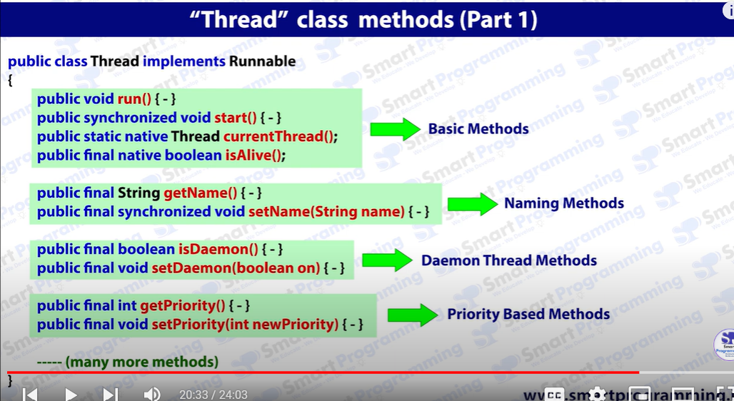

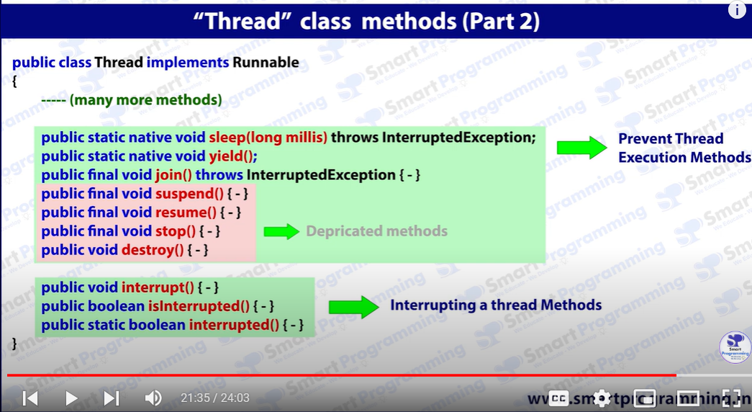

1. start()

Begins execution of the thread in a new thread of execution by invoking its run() method.

2. run()

Contains the code that defines the thread's task, typically overridden in subclasses or set by a Runnable target.

3. sleep(long millis)

Pauses the thread's execution for the specified amount of time in milliseconds.

4. join()

Waits for the thread to finish its execution before continuing the execution of the calling thread.

5. interrupt()

Signals the thread to stop its current task and handle an InterruptedException.

6. isAlive()

Checks whether the thread is still running or has completed its execution.

7. getName()

Retrieves the name of the thread.

8. setName(String name)

Assigns a new name to the thread.

9. getPriority()

Returns the thread's priority level (from 1 to 10).

10. setPriority(int priority)

Changes the thread's priority, influencing its scheduling by the JVM.

11. getThreadGroup()

Returns the thread group to which the thread belongs.

12. yield()

Temporarily pauses the current thread, allowing other threads of the same or higher priority to execute.

13. setDaemon(boolean on)

Marks the thread as a daemon thread, which runs in the background and terminates when all non-daemon threads finish.

14. isDaemon()

Checks if the thread is a daemon thread.

15. currentThread()

Returns a reference to the currently executing thread object.

16. activeCount()

Returns the number of active threads in the current thread's thread group.

17. checkAccess()

Determines if the currently running thread has permission to modify this thread.

18. interrupts()

Determines if the current thread has been interrupted.

19. setUncaughtExceptionHandler(UncaughtExceptionHandler handler)

Sets a handler for uncaught exceptions in this thread.

20. getState()

Returns the current state of the thread (e.g., NEW, RUNNABLE, BLOCKED).

See many thread has type native .. , that is this methods are built using may be different language just to enable multithreading in java.

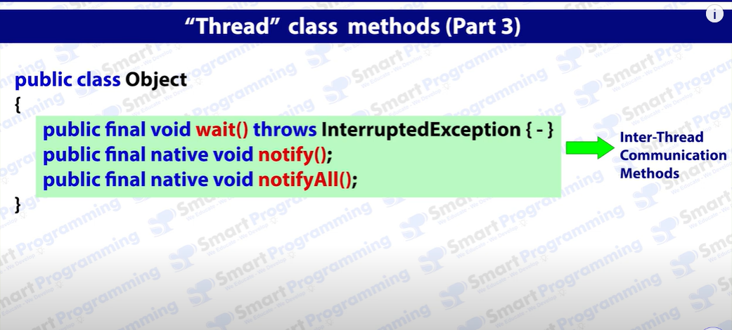

These are methods of Object class not thread class but used for inter communication methods btw threads.